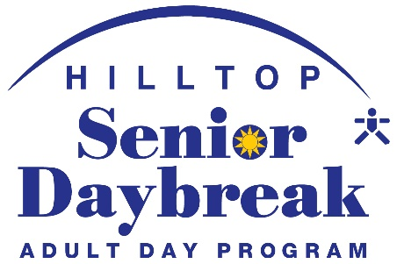

ENROLLMENT PACKET

Thank you for your interest in Senior Daybreak.
The following enrollment packet must be completed before a participant
may attend the program.

There are several pages that must be signed by a physician:

The Health Status Inquiry (page 4) and Medications List (page 5) must be reviewed and signed by a physician. If you are having difficulty obtaining these forms and signatures, please notify Senior Daybreak staff and we will try to help you.

The MOST form (Colorado Medical Orders for Scope of Treatment) (page 9) need only be completed and signed by a physician if the participant is a DNR - Do Not Resuscitate. Please read the attached yellow flyer explaining Advance Directives to better understand the purpose of this document.

Please call and make an appointment to return this packet to Senior Daybreak. We will go over the packet and discuss a schedule. If we will be transporting your loved one, we will need to work them into the current transportation schedule.
We will make a copy of this enrollment packet for you for your records.

Please call 241-7798 if you have any questions.

ENROLLMENT FORM
PARTICIPANT

Date

Participant’s Last Name: First Name: M.I.:
Social Security Number: Birth Date: Age:
Living Situation: ◻ by self ◻ w/spouse ◻ w/adult child ◻ w/other family member ◻ care facility Address: City: State: Zip:
Responsible Party: Relationship Phone:H:
Cell: Email
Billing: ◻ Private Pay ◻ VA - Social Worker: Ph _______

    ◻ Medicaid- Case Manager: Ph

◻ Current Hilltop resident? Y/N If yes, please indicate program_____________________________

GENERAL PERSONALITY TRAITS

Describe their personality:

FAMILY

Participant’s Marital Status: ◻ Single ◻ Married ◻ Divorced ◻ Widowed

Spouse Name (even if deceased):

# of Children: First Names:

Names and kind of important pets:

HISTORY
Ethnic Origin: ◻ White ◻ Black ◻ Hispanic ◻ Native American ◻ Asian ◻ Other Birth Place: Grew up where?:

Former Occupation(s):

Veteran? ◻ No ◻ Yes Branch of Service: List any major life events that the participant might talk about:

CURRENT ABILITY LEVEL
Mental Status: Awareness of People and Surroundings: ◻ High ◻ Medium ◻ Low
Confusion: ◻ None ◻ Mild ◻ Medium ◻ Extreme
Short term memory loss: ◻ None ◻ Mild ◻ Medium ◻ Extreme
Long term memory loss: ◻ None ◻ Mild ◻ Medium ◻ Extreme
Language: ◻ Conversational ◻ Some Difficulty ◻ Great Difficulty ◻ Non-Communicative
Walking: ◻ Independent ◻ Shaky or Unsure ◻ Cane ◻ Walker ◻ Wheelchair
Toileting: ◻ Independent ◻ Reminders ◻ Incontinent ◻ 1 person assist ◻ 2 person assist
Type of adult protective products used: Eating: ◻ Independent ◻ Needs Assistance Cutting ◻ Needs Supervision to Avoid Stuffing
◻ Needs to be Fed ◻ Special Diet (See Dietary Form) ◻ Dentures Bathing: ◻ Independent ◻ Needs Reminders ◻ Needs Assistance ◻ Usually a Battle Dressing: ◻ Independent ◻ Needs Assistance ◻ Needs to be Dressed by Caregiver Vision: ◻ Good ◻ Glasses ◻ Macular Degeneration ◻ Blind
Hearing: ◻ Good ◻ Poor ◻ Hearing Aids: ◻ Left ◻ Right
Smoking: ◻ No ◻ Yes: __Independent __Needs Supervision - Frequency: approx. per day

PHYSICAL LIMITATIONS

Describe limitations that would affect ability to do activities:

ACTIVITY INTERESTS

Past Activity Interests/Hobbies:

Current Activities:

Favorite kind of Music:

SPECIAL NOTES: Important things Daybreak should probably know:

PRIMARY CAREGIVER

Caregiver’s Name:

Relation to participant: ◻ Spouse ◻ Adult Child ◻ Grandchild ◻      -in-Law
◻ Sibling ◻ Other Caregiver’s Address: _City: -____ State: Zip: __Home Phone: Cell Phone: Work Phone:

How long has Caregiver been caring for participant? Does Caregiver have prior personal or professional caregiving experience? ◻ Yes ◻ No
Does Caregiver have family/friend physical support? ◻ Yes ◻ No Emotional support? ◻ Yes ◻ No

Current Caregiver Stress Level: ◻ Low ◻ Medium ◻ High ◻ Off the Charts!!!!!! Does Caregiver attend a support group? ◻ Yes ◻ No
Is Caregiver interested in learning more about: ◻ Support Groups ◻ Education Programs

Does Caregiver or family have any special hobbies, interests, or talents to share with Senior Daybreak (we are always looking for entertainers!)? ◻ Yes ◻ No
If yes, what?

How did Caregiver hear about Senior Daybreak?

The Participant and/or Caregiver choose to willingly participate in Senior Daybreak.
◻ Yes
◻ No

HEALTH STATUS INQUIRY
TOP SECTION TO BE COMPLETED BY RESPONSIBLE PARTY
BOTTOM SECTION TO BE COMPLETED & SIGNED BY PRIMARY PHYSICIAN

Participant: Date:

Age_
Birth Date Social Security (last 4)

Current Health Concerns:

Brief Past Medical History:

Allergies: Oxygen use: No Yes ( ___Liters p/m)
Mental Status:  No Confusion  Mild Confusion  Medium Confusion  Extreme Confusion Primary Physician: Physician Office Name: Physician Address: Physician Phone: Fax: Hospital Preference:
MEDICAL RELEASE
I hereby authorize (Physician’s name printed) to release the medical information below, and any other pertinent information necessary for the care and
health monitoring of the above-named participant/patient, to Senior Daybreak of Hilltop.

Date:
Signature of Responsible Party

Print Name Relationship to Patient

PHYSICIAN’S SECTION

Patient Diagnoses (include dementia if dx): Do you recommend the specialized adult day care services of Senior Daybreak?
for this patient?  Yes  No If no, why? ______________________________

Do you recommend any physical restrictions for this patient?  Yes  No

If yes, describe: Do you recommend any diet restrictions for this patient?  Yes  No
If yes, describe:

Have you referred this patient for:  physical,  occupational, or  speech therapy?   No

MEDICATION LIST

Participant Name:

Date:

Will prescription medications need to be given by staff at Senior Daybreak? yes no

Will over-the-counter medications need to be given by staff at Senior Daybreak?
__yes
__no

Please include all medications taken by participant on this sheet whether given at Senior Daybreak or not. This information is vital to give to medical personnel in case of emergency.

CURRENT PRESCRIPTION MEDICATIONS

Medication | Dosage | Time(s) of day  to be given | Purpose of  medication | Check if given  at Daybreak

CURRENT OVER-THE-COUNTER MEDICATIONS

Medication | Dosage | Time(s) of day  to be given | Purpose of  medication | Check if given  at Daybreak
Examples: Pain Relievers, Antacids, Stool Softeners, Cough Drops, Vitamins, Ointments, (etc.)

Any medication needed during program hours is brought in its original container so we may make a copy of the label. Medications will be stored in a locked closet and administered by a QMAP qualified person or RN, regardless of whether the participant might be cognitively capable of keeping medication on his/her person and self-administering. Are you in agreement with this Senior Daybreak policy for this Participant? yes _no___. If no, please call us to discuss.
MEDICATION POLICY
Senior Daybreak staff is qualified and trained to administer medications to participants.
The participant must be under a physician’s care and must be able to chew or swallow all medications as prescribed. The “Health Status Inquiry” must be on file with a physician’s
signature. This form is part of the initial enrollment paperwork. The medication list will be reviewed upon change, or annually with participant care plan and MOST form.

The family or responsible party is responsible for purchasing and providing all prescription and over the counter medications for the participant. All medications will be stored in a locked closet at Senior Daybreak until the medication is administered. Participants will not be allowed to keep their meds on their person, even if able to self- administer at home. All medications are charted when given. Staff medication errors are reported to the CDPHE MARE online reporting system, and to the SEP Case Manager if Medicaid.

All prescription medications must be brought to Senior Daybreak in its original container, and given to a Senior Daybreak staff member. We will then, make a copy of the label to attach to the medication Each medication should be in a clearly marked container with the following information on the container: participant’s name, medication name and strength, dosage, route of administration, time(s) of day to be administered and any special instructions as required. The container must have an active, non-expired date on it. If the participant takes more than one medication, EACH MEDICATION MUST BE IN A SEPARATE CONTAINER which is properly marked as above.

New medications or dosage changes MUST HAVE A PHYSICIAN’S ORDER before they can be administered
by Daybreak staff. Families or responsible party should ask the physician for this order at the time the medication is prescribed or changed. If it is not possible to get this piece of paper, then please notify Senior Daybreak staff and they will contact the physician and obtain this order by fax. Be advised this often takes
24 hours or more and the medication cannot be given until this order is on file.

It is important that Senior Daybreak be informed of any changes to medications, including the medications taken at home, so that records can be kept current. In the event of an emergency, the medication list on file is copied and given to emergency personnel.

Senior Daybreak staff cannot fill syringes or administer insulin shots to participants. However, staff can supervise a participant who is able to administer their own shot and blood glucose test. Arrangements can be made for the supervising RN to fill syringes as needed which are then stored in a locked refrigerator.

Medical marijuana CANNOT be administered or stored at Senior Daybreak.

RELEASE OF RESPONSIBILITY

I, (Responsible Party Name) understand that Senior Daybreak of Hilltop, Hilltop Health Services, Inc., and Senior Daybreak staff members are not responsible for any effects or health issues that arise as the result of administering medications given to participants per instructions of responsible party or physician. Neither will Senior Daybreak of Hilltop, Hilltop Health
Services, Inc. and Senior Daybreak staff be held responsible for failing to administer said medications, as the
result of oversight that results in serious effects or health issues.

Date

DIETARY INFORMATION

Participant Name:
Date:

Senior Daybreak receives the noon meal from The Commons Assisted Living which is a healthy, made-from-scratch, daily special. Senior Daybreak will provide the monthly menu to families at the beginning of the month. Morning and afternoon snack foods are purchased from Sam’s Club or the grocery store and are in compliance with USDA standards.

Senior Daybreak is not able to provide special diets such as gluten-free, diabetic, pureed, low salt (etc.). We can, however, provide sugar- free desserts. We do not put salt and pepper on the table, but will provide it to those who ask, and can monitor a person from adding more salt to their meal if necessary.

Senior Daybreak can provide salads or vegetables to those participants who are vegetarians, but the salad choices are very limited. Daily vegetables are greatly varied. Family may supplement proteins.

Senior Daybreak does not usually serve seconds. If a person has a large appetite we will give them a larger first serving.

Families can provide special beverages or food for their loved one if they so desire. These items should be sent daily or weekly. Other than sugar-free desserts, Senior Daybreak cannot purchase any special food items for individual participants.

Senior Daybreak can assist those participants who cannot eat independently.

Meal needs:  Regular Food  Soft Foods
❒ Diabetic but eats regular food, can have regular desserts
❒ Diabetic with strict restriction of sugar free desserts and monitored proportions
❒ Vegetarian  Low Salt

Food Allergies: Appetite is usually:  Large  Medium  Small
Food Likes:

Food Dislikes:

Preferred Beverages:  Water  Milk  Tea
❒ Coffee:  Black Cream  Sugar  Splenda  Other(s)
(Family to provide)

Diet notes:

EMERGENCY INFORMATION

Participant Name:
Date:

If there is a medical emergency, Senior Daybreak staff will call the primary caregiver and the supervising nurse at the same time. Based on the circumstances, and input from both the nurse and the primary caregiver, a judgment call will be made on whether to call 911 for emergency personnel and ambulance transport, or non-emergency ambulance transport, or pickup by the
caregiver to be taken to the ER, doctor, or home. Please list the proper individuals to call in case of
an emergency.

Primary Caregiver: Relationship: Address: City: Zip:
Home: Work: Cell:

2nd Contact Person: Relationship: Address: City: Zip:
Home: Work: Cell:

3rd Contact Person: Relationship: Address: City: Zip:
Home: Work: Cell:

ADVANCE DIRECTIVES

A participant is not required to have advance directives in place to attend Senior Daybreak, but
Senior Daybreak is required by the state to ask if directives are in place and to provide information
to the family if not. (See Advance Directives flyer in packet for explanation of the following directives). Check the directives that have been established:

❒ Durable Medical Power of Attorney
Name of POA Agent:_ Phone:_
❒ Durable Financial Power of Attorney
Name of POA Agent:_ Phone:_
❒ Living Will  Organ Donor
❒ CPR Directive: Do Resuscitate DO NOT Resuscitate (DNR) 

 If your loved one is a DO NOT RESUSCITATE, please complete the MOST form (see next page), or provide a copy if you have already completed one. This form must be signed by the physician. Senior Daybreak MUST HAVE A SIGNED COPY ON FILE IF THE PARTICIPANT IS A DNR. Senior Daybreak does not need copies of the Power of Attorney, Living Will, or Organ Donor documents.

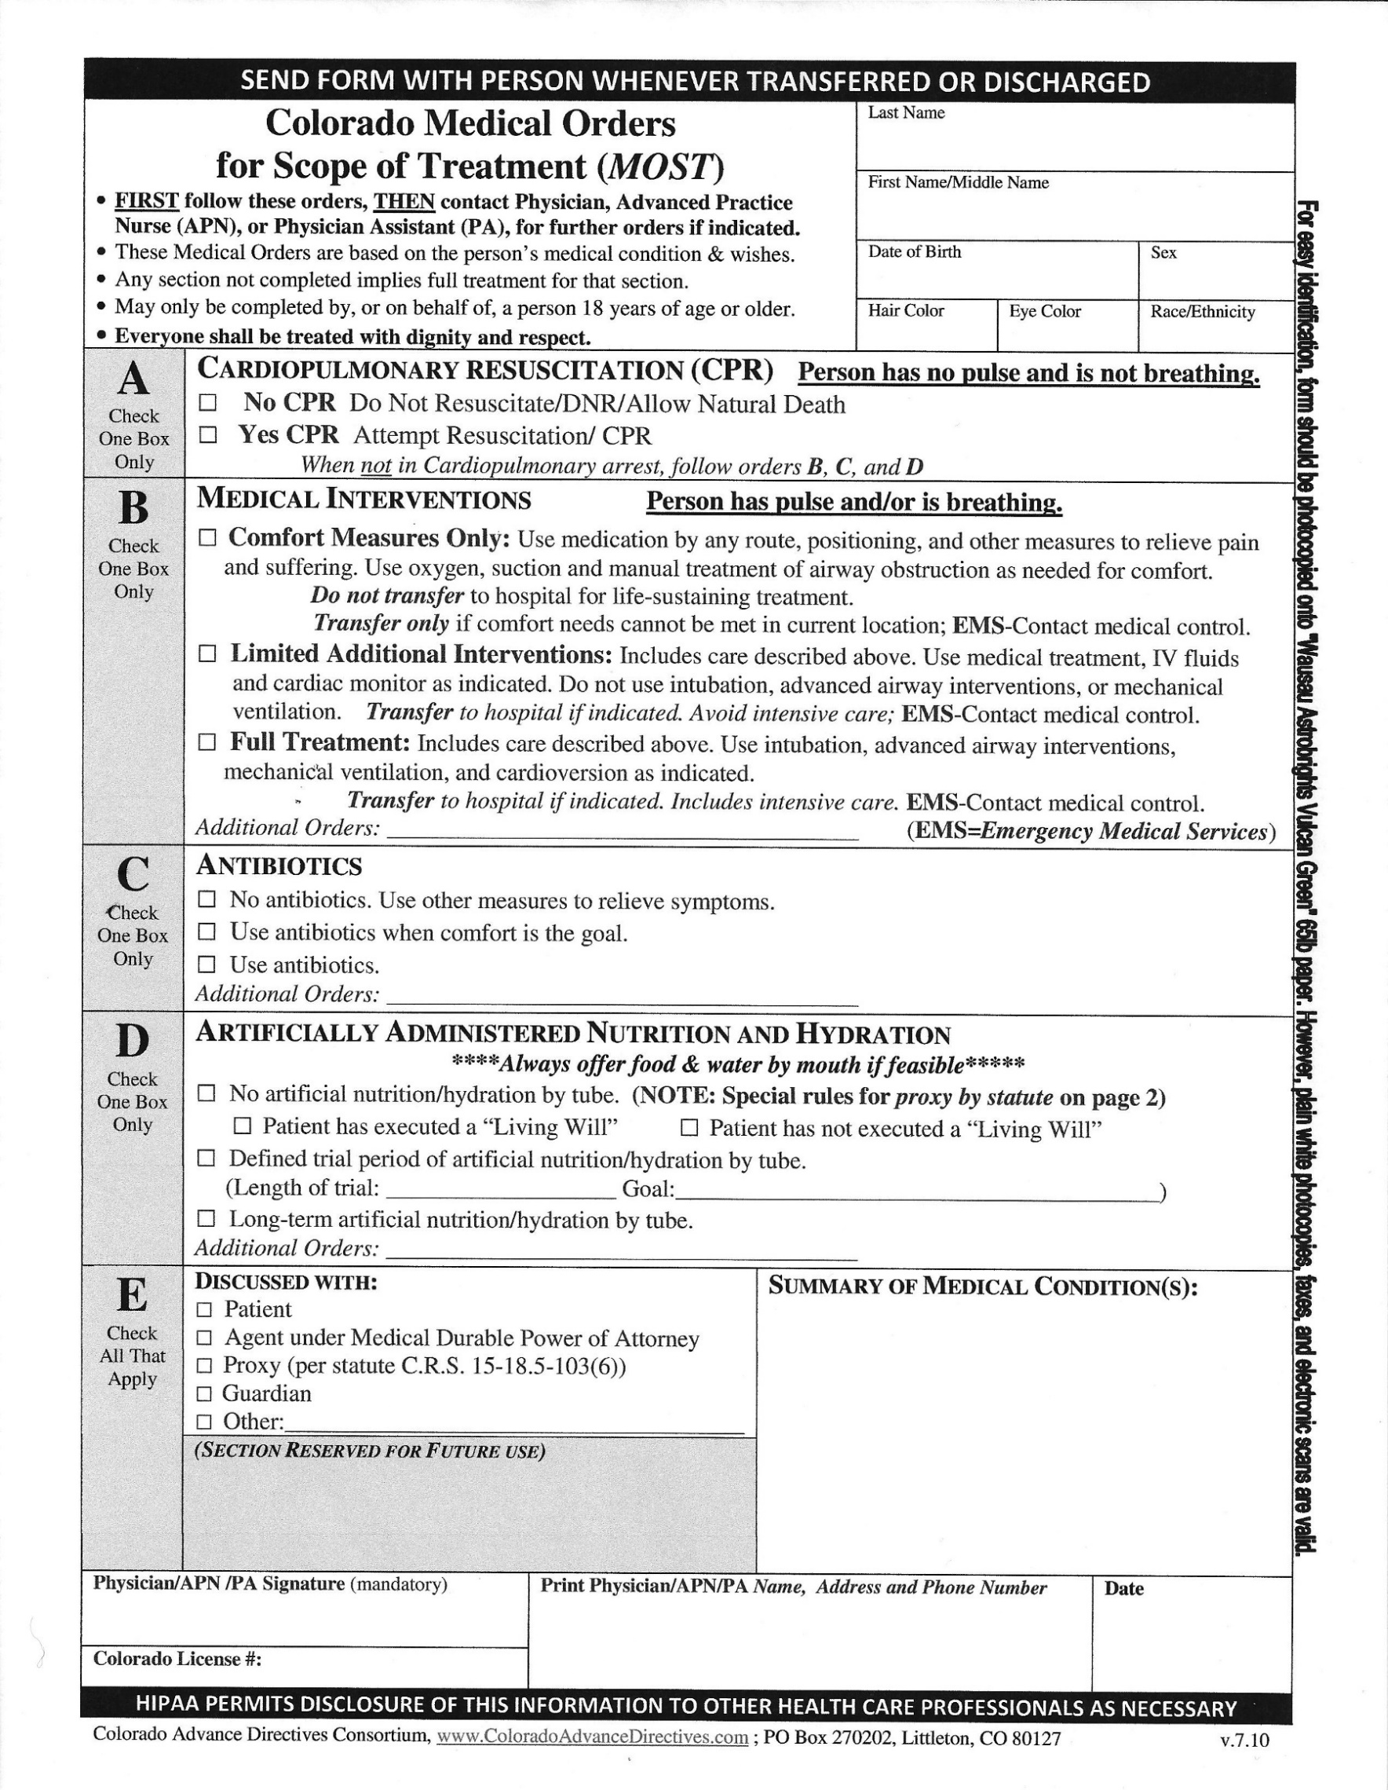

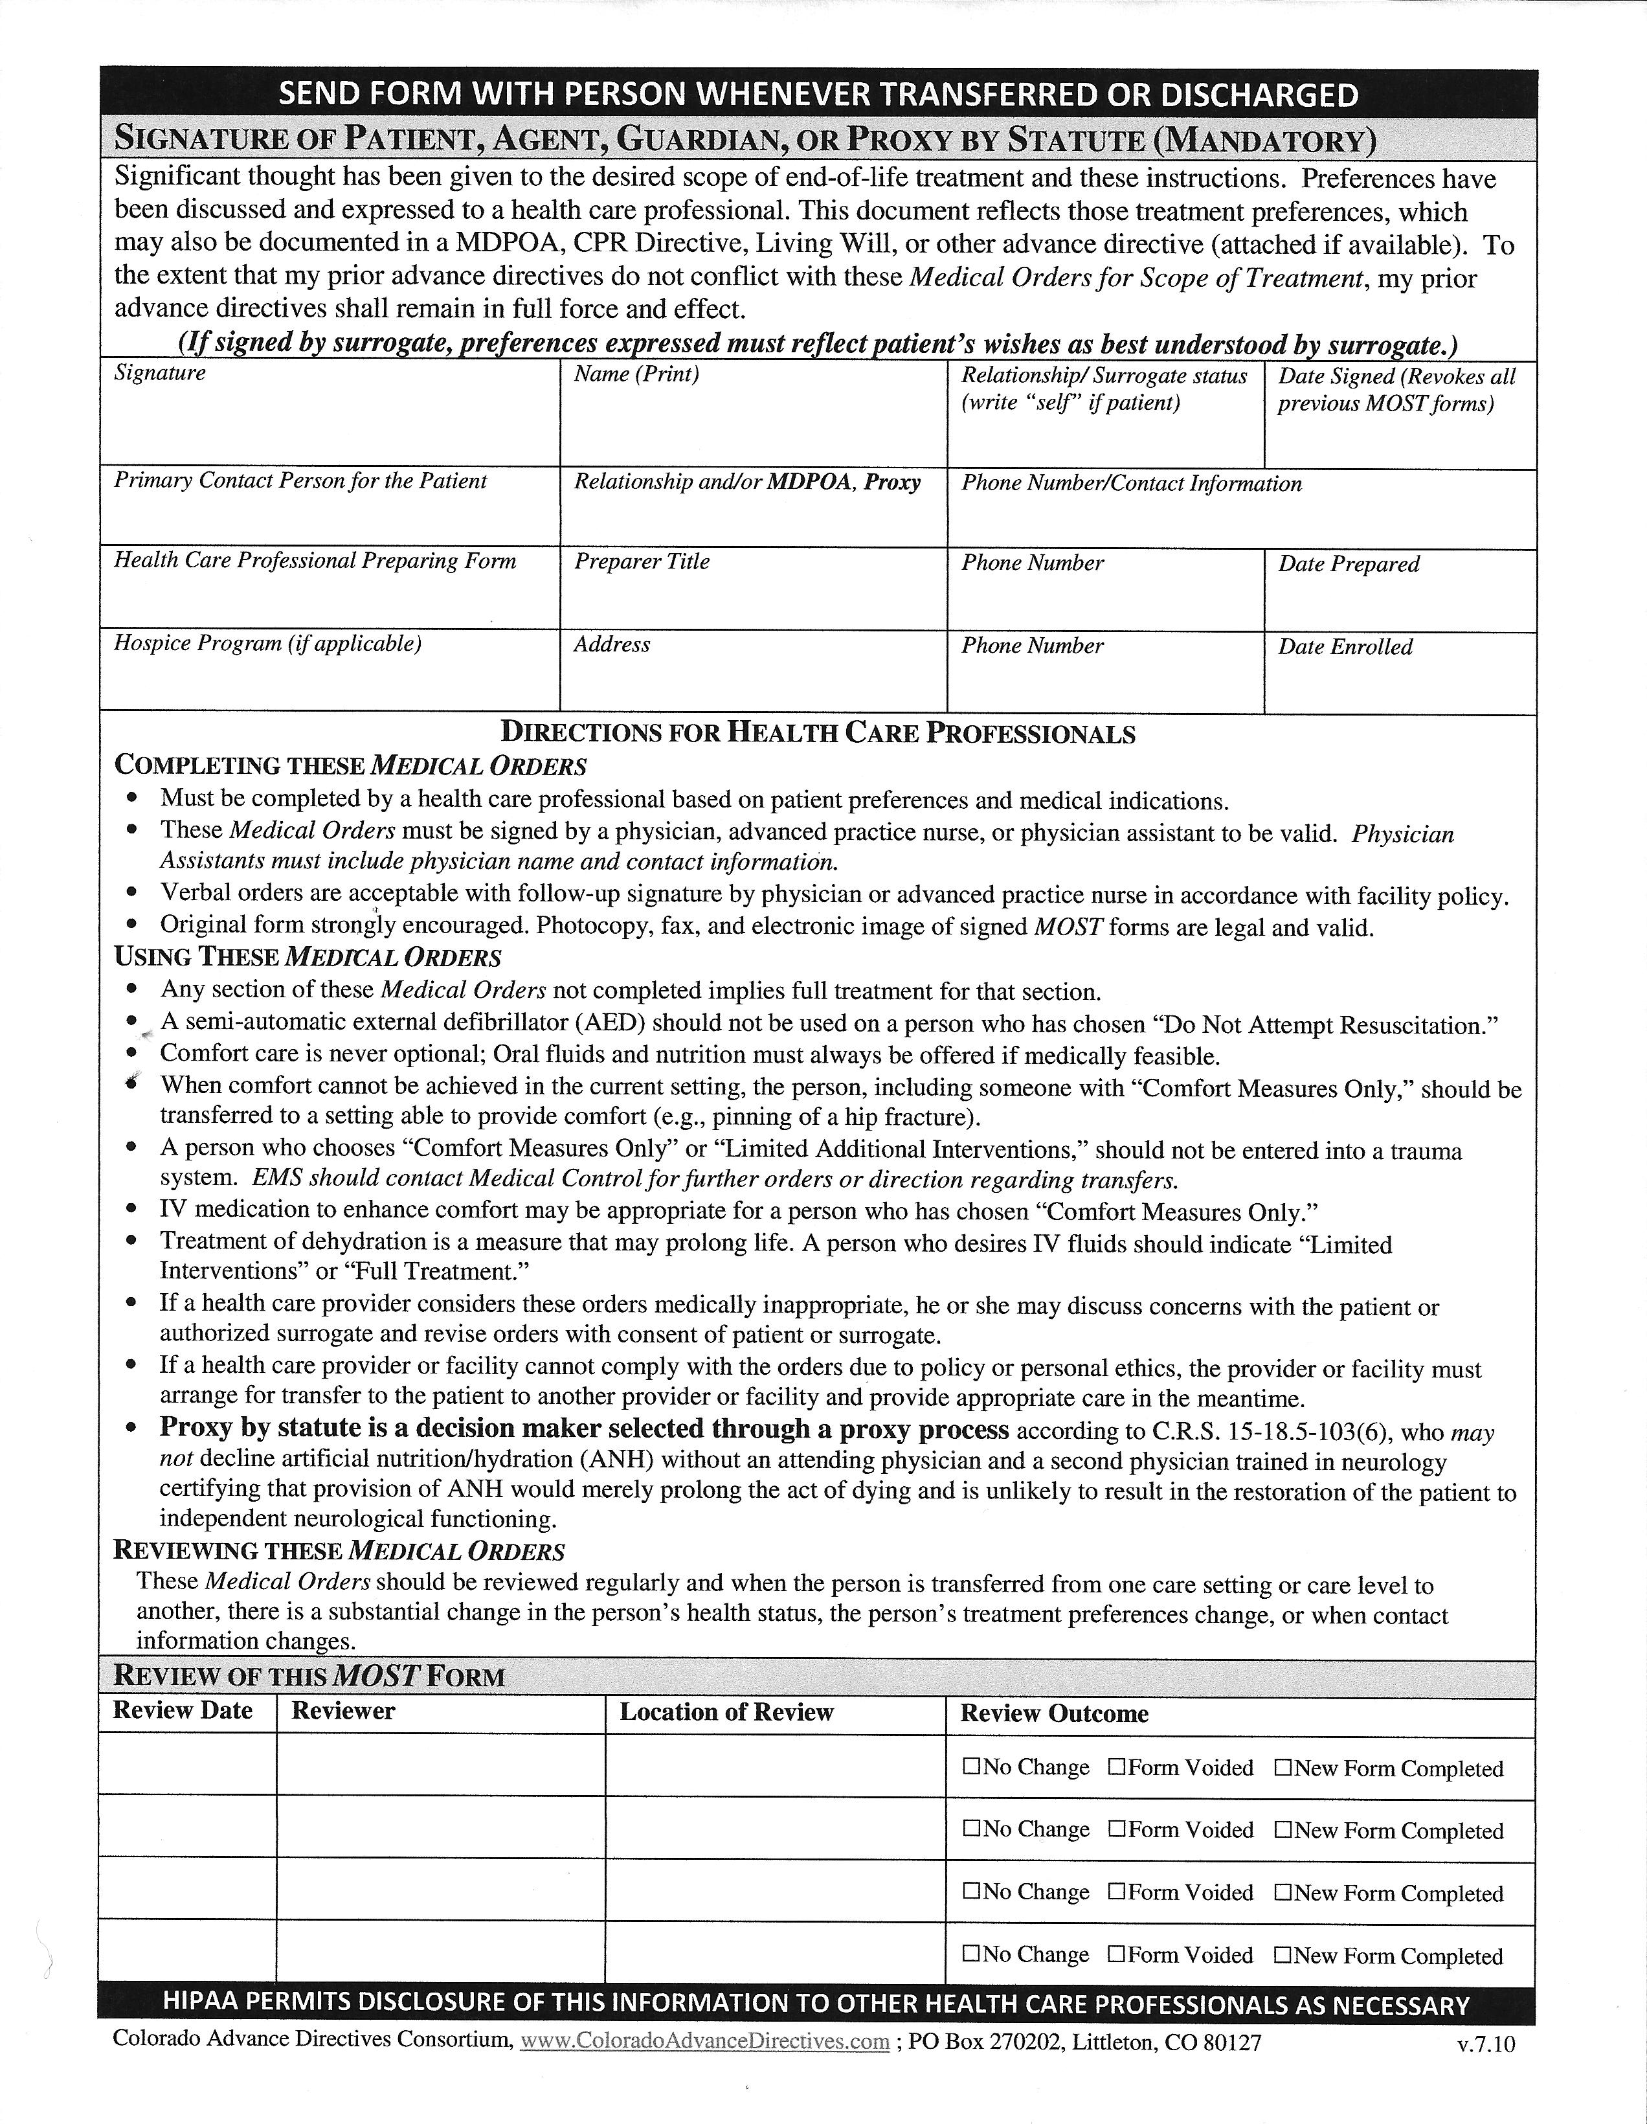

PERMISSION FORM

Participant Name:
Date:

MEDIA MATERIALS

Senior Daybreak of Hilltop shall have permission to use photographs or videos taken of the above-named participant for educational and instructional purposes or for the purpose of promoting Senior Daybreak services and programs. Photographs or videos could potentially be used in newsletters to SDB families, newspapers, power point presentations, television, brochures, flyers, or any other media that Hilltop Director or Marketing and Development team deems appropriate.

I HAVE READ AND UNDERSTAND THE ABOVE PARAGRAPH, AND HEREBY GIVE MY PERMISSION AND CONSENT FOR USE OF MY PICTURE IN MEDIA MATERIALS.

Yes No

Date
Signature of Participant or Responsible Party

FIELD TRIPS

Senior Daybreak of Hilltop shall have permission to allow the above named participant to be transported for activities or field trips outside of the Senior Daybreak facility. The activities will be held within a reasonable distance from the Senior Daybreak facility and will be held during Senior Daybreak hours of operation, or during special hours of operation for evening or weekends on occasion. Transportation will be provided and will include assistance for those in wheelchairs or those using walkers. Such activities shall be planned with consideration for the physical capabilities of our participants.

I HAVE READ AND UNDERSTAND THE ABOVE PARAGRAPH, AND HEREBY GIVE MY PERMISSION TO GO ON LOCAL FIELD TRIPS/SCENIC VAN RIDES.

Yes No

Date
Signature of Participant or Responsible Party

Hilltop Health Services Corporation
Waiver and Release of Liability
1. By signing this Waiver and Release of Liability (Agreement), I waive and release Hilltop Health Services Corporation, its agents, servants, employees, insurers, successors and assigns from any and all claims, demands, causes of action, damages or suits at law and equity of any kind, including but not limited to claims for personal injury, property damage, medical expenses, loss of services, on account of or in any way related to or growing out of my presence or involvement at the facility.

This waiver and release is intended to and does release Hilltop Health Services Corporation from any and all liability for damages or injuries on account of or in any way related to or growing out of my negligence, the negligence of third parties and Hilltop Health Services Corporation’s negligence. This is not intended to release Hilltop Health Services Corporation from any liability resulting from their intentional conduct.

I further covenant and agree not to institute any claims or legal action against Hilltop Health Services Corporation for any claim released by this Agreement. I further agree that should any claim be made against Hilltop Health Services Corporation in contravention of this Agreement, including but not limited to derivative claims, I will protect, defend and completely indemnity (reimburse) Hilltop Health Services Corporation for any such claim and expenses including attorney’s fees and costs incurred by Hilltop Health Services Corporation in defending themselves or security indemnity hereunder.
2. I understand that Hilltop Health Services Corporation is not responsible for any lost, stolen, or damaged valuables or property.
3. I acknowledge that I have received and read a copy of the current rules and regulations governing the use of the facility. I agree that I will fully comply with all rules and regulations and with any amendments.
I have read the Agreement and understand that by signing the Agreement I have consented to be bound by its terms, including the waiver/release of any legal right I may have to sue Hilltop Health Services Corporation for any costs they incur because a claim or legal action is brought in violation of this Agreement. I agree any violation of the Agreement and its terms and conditions, as determined by Hilltop Health Services Corporation, will void and terminate this Agreement and may result in loss of the ability to use the facility.
I am signing this Agreement freely, voluntarily and competently and am at least eighteen (18) years of age.
Name (please print) ____________________________________________________________________
Signature ________________________________________________________ Date _______________
This Waiver and Release of Liability Form is a guideline. It does not address potential compliance issues with federal, state or local law, and it is not meant to be exhaustive or construed as legal advice. The contents of this waiver, and the extent of its effectiveness in court, may be affected by state law. Consult your licensed commercial property and casualty representative at Home Loan Insurance or legal counsel to address possible compliance requirements.
©2013 Zywave, Inc. All rights reserved.

Participant Printed Name: _______________________________________________________________

SERVICE AGREEMENT

Participant Name:
Date:

Responsible Party:
Relationship:

This agreement defines the responsibilities of both Senior Daybreak and the Responsible Party. This agreement is not a contract locking the Participant into attending for a required amount of time.

Before a participant can attend, all ENROLLMENT PAPERWORK must be completed and signed by Responsible Party and returned to Senior Daybreak for review.

This agreement between SENIOR DAYBREAK, and RESPONSIBLE PARTY shall be in effect for one year from start date and can be renewed annually:
Start Date _, and End Date (one year from start date) .

ADMISSION POLICY
Senior Daybreak participation is open to all persons without regard to gender, race, ethnic heritage, religious background, or sexual orientation, in compliance with Title VI of the Civil Rights Act of 1964. Participants will be accepted on a space-available basis, providing they meet the following criteria.

ADMISSION CRITERIA
Participants shall be admitted who are:

• Seniors (50+ years of age) who will benefit from socialization and stimulation in a safe and supportive day care program environment, to include those who are cognitively impaired, developmentally disabled, or medically fragile.
• Able to bear enough weight to transfer from one chair to another or to the toilet either independently or with a 1 or 2 person assist. Participants who require full lifting will not be admitted.
- Participants can utilize a manual wheelchair- if they can still bear weight to assist in transfers. The use of a Powerchair or scooter within the building will need to be assessed and approved by staff prior to admission to ensure use of device does not cause a safety risk to others or potential property damage.
• Able to be congenial with other participants and staff, with no behaviors that would risk their own safety or the safety of the other participants and staff.
• Able to adhere to Senior Daybreak’s non-smoking policy which prohibits smoking inside the facility and allows smoking only in a designated outside area.
• Free of contagious diseases.

PROGRAM CAPACITY
Senior Daybreak has room for up to 30 participants per day. If this capacity is reached, potential participants will be placed on a wait list and notified when space is available.

SERVICES PROVIDED
Senior Daybreak will provide the following services which are included in both the half or full- day fee:
• socialization and conversation
• stimulating mental and physical activities appropriate to ability level
• assistance with toileting and incontinence if needed
• assistance with walking or transferring from one location to another if needed
• morning and afternoon snacks and noon meal with hydration throughout the day
• daily monitoring and reporting to families of health concerns by staff, periodic (usually monthly) wellness checks by an LPN or RN, with monthly weight, blood pressure and pulse recorded
• medication administration by qualified staff with doctor’s orders
• supervision and protective oversight in a secure environment
• occasional field trips appropriate to the individual’s cognitive ability
SENIOR DAYBREAK DOES NOT PROVIDE CONSTANT 1:1 CARE, NOR PROMISE “LINE OF SIGHT” AT ALL TIMES. THIS MEANS PARTICIPANTS ARE FREE TO USE ALL SPACES OF THE FACILITY INDOORS, AND OUT WHEN WEATHER-APPROPRIATE.

Senior Daybreak can provide the following OPTIONAL SERVICES for an additional fee. These optional services are not covered by Medicaid or the VA (except for transportation):

• Transportation: pick up to and from Senior Daybreak with Hilltop van

FINANCIAL AGREEMENT – PROGRAM FEES

Senior Daybreak program fees are as follows: (Subject to change with 30 day notice.)

Full day (over 4 hours) $ 117.00
Half day (4 hours or less) $ 58.50
Transportation (optional) $ 2.50 per mile for Private Pay. Medicaid or VA participants will need authorization from caseworkers for coverage of transportation to be paid.

PRIVATE PAY: ◻ Private Pay Participant

Bills mailed to:
Relation to Participant

Address: Email

City, State, Zip
Phone

Fees will be billed on the fifth of the month for the previous month. Bills will be mailed to
Responsible Party. Payment is due upon receipt.

Participants will be billed only for actual days of attendance. Fees will not incur if participant misses a scheduled day for illness, vacation, or other reason.

Should the account become more than sixty (60) days in arrears, participation in Senior Daybreak program will be suspended until the account is current.

MEDICAID: ◻ Medicaid Participant in process

A Participant must already be qualified for Medicaid and assigned a Case Manager in order for Senior Daybreak to receive payment from Medicaid. This Case Manager will approve the Participant to attend from 1-5 days per week based on the responsible party’s decision of number of days desired. The Case Manager will fax or mail a PAR to Senior Daybreak which is a document stating the total days of authorization for the year. The Participant can attend less days per week, but should not attend more, although it is the total units per month that count. So, a short week could offset a long week. The number of days desired can be increased at any time by contacting the Case Manager then the Senior Daybreak Director.

If transportation is desired, the Case Manager will also authorize either a one or two way trip. Families can choose the provider – either Senior Daybreak or a taxi service.

Medicaid will be billed on the fifth of each month for the previous month. Senior Daybreak will mail a copy of the bill to the Participant’s Responsible Party.

If a Participant attends Senior Daybreak before qualifying for Medicaid and receiving authorization,
the Participant’s Responsible Party will be responsible for payment of service.

VETERANS: ◻ VA Participant ◻ In process

A Participant must be registered in the Veterans Administration system and the Responsible Party must speak to one of their Social Workers about the Participant attending in order for Senior Daybreak to receive payment from the VA. This Social Worker will authorize the Participant to attend from 1-5 days per week based on the responsible party’s decision of number of days desired. The Social Worker will verbally approve and fax authorization to Senior Daybreak. The Participant can attend less days per week, but cannot attend more than what is authorized. A short week cannot offset a long week. The number of days desired can be increased at any time by contacting the Social Worker then the Senior Daybreak Director.

If transportation is desired, Senior Daybreak will provide either a one or two -way trip. Using a taxi service is not an option for VA Participants. Participants must accommodate to Daybreak’s schedule.

The VA will be billed on the fifth of each month for the previous month. Senior Daybreak will mail a
copy of the bill to the Participant’s Responsible Party.

If a Participant attends Senior Daybreak before speaking to the VA and receiving authorization, the
Participant’s Responsible Party will be responsible for payment of service.

SCHOLARSHIP OPPORTUNITY

Senior Daybreak does receive, at times, grant money that can be awarded to families as
scholarship funds in the form of credit towards a participant’s Senior Daybreak bill. Families
who need financial assistance in order to send their loved one to Senior Daybreak may apply for
these scholarship funds by contacting the Director, and checking the “yes” box below. These
scholarship funds are awarded to private pay families only.

These funds are not guaranteed and the amount available to credit to families can change on a monthly and annual basis. The amount available is dependent on the number of families requesting assistance.

In compliance with grant funds that Senior Daybreak receives from the Area Agency on Aging
based on the OLDER AMERICAN ACT, the following information must be provided for families:

• A WAITING LIST will be established when the facility is at full capacity (30) and the participants’ comfort and safety would be compromised due to lack of space and inadequate accessibility to lavatory facilities. Although persons on the waiting list will be considered, priority for a vacancy will be given to persons who have an emergency need, with particular attention to low-income and older individuals residing in rural areas. If a vacancy is given to someone other than a person who has been on the waiting list the longest, the date and reason(s) shall be documented.

• All persons aged 60 and older are eligible to receive services supported by the Older American Act. If sufficient resources are not available to serve all eligible individuals who request a service then preference will be given to those of greatest social or economic need with particular attention to low income minorities. An individual income may be one of several factors considered for prioritizing clients for service. However, a means test may not be used to deny services to any individual.

Participant Name:

Responsible Party to Contact:

Yes, we are interested in applying for financial assistance.

No, we have no need for financial assistance at this time.

HOURS OF OPERATION & SCHEDULE
Senior Daybreak is open Monday - Friday, 7:50 a.m. – 4:50 p.m. (8-5) Participants may not be dropped off before 7:50 and must be picked up no later than 4:50 p.m. or a late fee of $10.00 for each 15-minute increment past 4:50 will be charged.
Senior Daybreak will be closed for holidays and severe weather.

Participants are encouraged to establish a set schedule, if possible. Occasional or drop in attendance is also acceptable, if space is available. A phone call the day before is required to verify
space availability and to allow Senior Daybreak to order the correct amount of food for lunch.

◻ Projected Starting Schedule: Mon
Tues
Wed
Thu
Fri__

Arrival time: _
Departure time:

Senior Daybreak tries to be as flexible as possible to accommodate the needs of the family. However…if possible, families should notify Senior Daybreak if they know in advance that a Participant will miss a scheduled day in the program. This will allow Senior Daybreak time to cancel the meal order, usually placed at 2 p.m. for the next day.

A schedule can be changed at any time by contacting Senior Daybreak staff.

TRANSPORTATION
Senior Daybreak offers transportation for pickup and delivery of participants to the program. New Participants will be worked into the current transportation schedule in a logical and practical fashion, if possible. There is no guarantee that Senior Daybreak can pick up or deliver a Participant at the family’s exact desired time. PLEASE ALLOW A 30-MINUTE WINDOW ON EACH SIDE.
Families must accommodate to Senior Daybreak’s transportation schedule if they desire to utilize this optional service. Senior Daybreak transportation is not as flexible as a taxi service. There is only one run to Fruita in the morning (8:00-8:30 am) and one run to Fruita in the afternoon (leaves Daybreak at 4:00 pm). Pick up/drop off spot must have room for driver to park and move safely in and out, or family/caregiver may be asked to meet the bus with participant in a safe area.

The Senior Daybreak driver can provide assistance in and out of the participant’s door and is
knowledgeable in understanding and caring for seniors with dementia.

The Responsible Party must notify Senior Daybreak of any transportation changes or cancellations, with enough notice to prevent the driver from making a wasted trip.

◻ Primary Caregiver/Family transport one way both ways

◻ Senior Daybreak transport one way both ways

◻ Participant CAN be left home alone if no family member is present at drop off

◻ Participant CANNOT BE LEFT HOME ALONE if no family member is present at drop off. Driver will attempt to contact Emergency Contact Person, and if unsuccessful, will return Participant to Senior Daybreak. Family will then be required to come pick up before 5:00.

MEDICATIONS
Refer to Medication Policy, page 6. In summary, Participant must have a physician- signed
medication list on file. Meds must be brought to Senior Daybreak in original container. Each med must be in a separate, clearly labeled container.

MEDICAL MARIJUANA
Senior Daybreak staff is not allowed to dispense medical marijuana in any form. Participants are not allowed to bring medical marijuana to Senior Daybreak.

BEHAVIOR EXPECTATIONS
Behaviors typical of dementia are expected and worked with. Families must accept and
understand that some socially inappropriate language and behaviors will occur, despite Senior Daybreak staff’s best effort to prevent and intervene. Physical aggression towards other participants or staff is not acceptable, but may happen on occasion. If this aggression is not an isolated event, and cannot be squelched with redirection or medication, this participant will not be allowed to continue attending the program. Staff is well- trained in dealing with difficult and challenging behaviors and will do so with patience, respect and dignity towards all participants.

EXTRA CLOTHING
Responsible Party shall send on the first day of attendance an extra set of clothing that can be kept
at Senior Daybreak in case the Participant has a beverage spill or incontinence requiring a change. These items shall include an extra shirt, pants, and pair of underwear (if applicable – adult protective brief pullups or pads). All clothing items will be stored in separate bin for each Participant. When clothing is soiled, it will be sent home for washing to the family, who should then return another set on the next visit.

ADULT PROTECTIVE BRIEFS
If a participant is incontinent requiring the use of adult protective briefs, please supply their individual supplies. If on an incontinence plan, staff will offer toilet, assist and change the participant during the day as needed. If assistance is needed with supplies, please speak to staff about options.

SMOKING
Smoking is allowed if the participant can do so independently outside in the designated back patio
area. All cigarettes and lighters must be kept at the nurse’s station for the safety of all. Smoking is not permitted for those participants with dementia who obsess or constantly ask for a cigarette, requiring constant one-on-one staff supervision and smoking assistance.

MONEY
Since participants are not required to have any money for the program, they are discouraged from bringing over $5.00 with them.

PERSONAL ITEMS & JEWELRY
Personal items may be brought to Senior Daybreak, including hobby items i.e. knitting, crocheting
supplies, etc., as long as they do not interfere with the safety, health, or comfort of other participants. Expensive jewelry should not be worn, especially if the Participant has a tendency to take such items off or to give to others, which is a typical dementia behavior. Senior Daybreak will not be held responsible for the loss of any personal or jewelry items.

LIQUOR
Liquor will not be provided at Senior Daybreak. Participants cannot bring liquor to the program.

AIDS
Staff should be informed of all aids the Participant will have or use during program hours. For example, dentures, eyeglasses, canes, walker, wheelchair, etc. When possible these items should be marked with participant’s name. Senior Daybreak will not be responsible for aids lost or broken during program hours though great effort will be made to keep items safe.

NAME BADGE
All Participants will wear a name badge with their first name only provided by Senior Daybreak.

PETS
No personal pets are to be brought to the program. Pet therapy animals are brought in on occasion.

GIFTS
Senior Daybreak staff is not allowed to accept gifts or money from Participants or families. The
exception to this rule is at Christmas. Small tokens of appreciation are acceptable. Money and expensive gifts specifically to staff members are not acceptable. Financial donations or in-kind donations to the Senior Daybreak program or Hilltop in general are always welcome.

PRIVATE CAREGIVING
Senior Daybreak staff is not allowed to provide private caregiving services to Participants in the
Participant’s home. Staff can provide a list of home health care agencies in Grand Junction.

TERMINATION POLICY
Families may remove or cease to bring Participants to the program at any time with verbal notice. Termination of a participant that has health issues or behaviors beyond the scope of the care of the Senior Daybreak staff. This is evaluated on an individual basis and is at the discretion of the Senior Daybreak Manager and Supervising Nurse.

GRIEVANCE PROCEDURE
A Participant of Senior Daybreak, or Responsible Party, has the right to present grievances on
behalf of him/herself or others to Senior Daybreak Program Manager Tabby Wiiest (970-773-2263) or Hilltop Senior Living Community Director, Jon Tadvick (244-0761), without fear of reprisal. Participants and families are encouraged to join with staff and administration to work for improvements in programming. Representatives of the Participant may also contact the local Area Agency on Aging (970-248-2717) or the State Unit on Aging at (303-866-2800).
------------------------------------------------------------------------------------------ I have read and understand the contents of this agreement, and agree to all the terms and responsibilities included.

Responsible Party Date

Manager / Designee Date

Dear Family,

We are now able to get reimbursement for our some of our food costs from the USDA Food Program. This is your assurance our meals and snacks are in compliance with USDA standards and the reimbursement helps with our program costs. In order for us to receive these funds, you must fill out the form on page 22. This will need to be reviewed and re-signed annually. The letter on the next page, page 21, is their official letter which explains what to fill out in more detail, but it is a bit confusing.
Basically:
At the top where it asks for “Your Name”, this means your loved one, the
person who is the Senior Daybreak participant. (Not you)
If participant is private pay or VA it does ask for participant income information. This determines the amount we are reimbursed per meal and snack. Please rest assured this information is seen by no one but myself and the USDA auditor. This private information is kept locked in my office. Private pay and VA participants should complete Part 1, 3, 4 and 5 – you can skip Part 2. Medicaid participants should complete Part 1, 2, 4 and 5 – you can skip Part 3.
At the bottom where it asks for Signature of Person Completing Form, that is you, the caregiver.
Don’t hesitate to call with questions. Thank you for your cooperation!

Sincerely,
Senior Daybreak of Hilltop

In accordance with Federal civil rights law and U.S. Department of Agriculture (USDA) civil rights regulations and policies, the USDA, its Agencies, offices, and employees, and institutions participating in or administering USDA programs are prohibited from discriminating based on race, color, national origin, sex, disability, age, or reprisal or retaliation for prior civil rights activity in any program or activity conducted or funded by USDA.
Persons with disabilities who require alternative means of communication for program information (e.g. Braille, large print, audiotape, American Sign Language, etc.), should contact the Agency (State or local) where they applied for benefits. Individuals who are deaf, hard of hearing or have speech disabilities may contact USDA through the Federal Relay Service at (800) 877-8339. Additionally, program information may be made available in languages other than English.
To file a program complaint of discrimination, complete the USDA Program Discrimination Complaint Form, (AD-3027) found online
at: http://www.ascr.usda.gov/complaint_filing_cust.html, and at any USDA office, or write a letter addressed to USDA and provide in the letter all of the information requested in the form. To request a copy of the complaint form, call (866) 632-9992. Submit your completed form or letter to USDA by:
(1) Mail: U.S. Department of Agriculture
Office of the Assistant Secretary for Civil Rights
1400 Independence Avenue, SW
Washington, D.C. 20250-9410; (2) Fax: (202) 690-7442; or (3) Email: program.intake@usda.gov.

SENIOR DAYBREAK 20

